**Stories 3: Infra metrics - Node Exporter - Prometheus - Grafana**



**INTRODUCTION TO PROMETHEUS AND GRAFANA**

**ARHCITECTURE OF PROMETHEUS**

**PROMETHEUS INSTALLATION ON LINUX**

**NODE EXPORTER ON APPLICATION**

**CONFIGURATIONS OF PROMETHEUS WITH NODE-EXPORTER SCRAPING THE METRICS FROM THE APPLICATION SERVER**

**GRAFANA INSTALLATION**

**CONFIGURING PROMETHEUS WITH GRAFANA**

Stories 3: Infra metrics - Node Exporter - Prometheus Grafana 1

**GRAFANA DASHBOARDS FOR APPLICATION SERVER**

**Prometheus and Grafana**

Prometheus and Grafana two powerful tools that are used for monitoring and visualization in the world of cloud technology.

Prometheus is an open-source monitoring and alerting system, while Grafana is a feature-rich data visualization platform.

Together, they form a robust combination that helps organizations gain insights into their systems' performance and health.

**Introduction to Prometheus**

*Prometheus as a monitoring and alerting toolkit*

*Developed at SoundCloud*

*Built with a focus on reliability, scalability, and simplicity*

*Core components: Prometheus Server, exporters, and client*

*Prometheus provides several key features that make it a powerful monitoring tool:*

Stories 3: Infra metrics - Node Exporter - Prometheus Grafana 2

***Data Collection:***

*Prometheus collects metrics from various sources, including HTTP endpoints, exporters, and client libraries. It supports dynamic service discovery, allowing it to automatically discover and monitor new instances as they come online.*

***Data Storage:***

*Prometheus has its own built-in time series database (TSDB) that efficiently stores and indexes collected metrics. The TSDB allows for efficient querying and analysis of historical data.*

***Query Language:***

*Prometheus uses PromQL (Prometheus Query Language) to query and aggregate collected metrics. PromQL allows users to perform powerful and flexible queries to extract specific information from the collected data.*

***Alerting:***

*Prometheus has a built-in alerting mechanism that allows users to define alerting rules based on metric thresholds or more complex conditions. When an alert rule is triggered, Prometheus can send notifications to various integrations, such as email, PagerDuty, or slack .*

***Visualization:***

*While Prometheus itself provides a basic web-based interface for querying and exploring metrics, it is often used in conjunction with visualization tools like Grafana. Grafana integrates with Prometheus to provide a feature-rich, customizable dashboarding and visualization experience.*

**Time Series Database:**

Prometheus uses its own time-series database for storing collected metrics. The data is stored in a compressed and efficient format, enabling quick retrieval and analysis.

Stories 3: Infra metrics - Node Exporter - Prometheus Grafana 3

***ARCHITECTURE OF PROMETHEUS 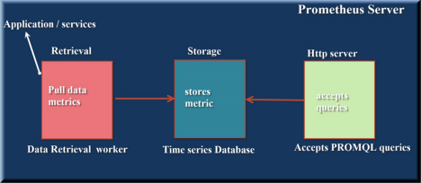*Lab :**

Launch Three Servers

Stories 3: Infra metrics - Node Exporter - Prometheus Grafana 4

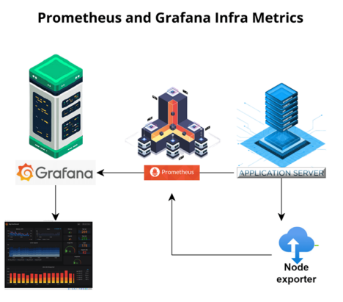

Install Prometheus in Prometheus server, Application server and grafana server

| Server 1 | 1.   Prometheus Installation on Linux |  |
| --- | --- | --- |
| Server 2 | 2. Application Server |  |
| server 3 | 3. Grafana Server |  |

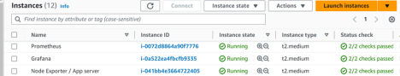Stories 3: Infra metrics - Node Exporter - Prometheus Grafana 5

Server 1 (Prometheus server)

**Launch the Ubuntu version 20 Virtual Machine:**

Install the ubuntu version 20 from the AWS Cloud

Allow the Inbound rule 9090 which is the port number of Prometheus To install the Prometheus visit the official website site https://prometheus.io For the Installation of Prometheus we have created a below script file

Name of the script file is sh Prometheus repo

**https://github.com/mubeen507/Prometheus.git**

https://github.com/prometheus/prometheus/releases/download/v2.50.0- rc.1/prometheus-2.50.0-rc.1.linux-amd64.tar.gz

!#/bin/bash

sudo apt update

sudo wget https://github.com/prometheus/prometheus/releases/down sudo groupadd --system prometheus

sudo useradd -s /sbin/nologin --system -g prometheus prometheus sudo mkdir /var/lib/prometheus

sudo mkdir -p /etc/prometheus/rules

sudo mkdir -p /etc/prometheus/rules.s

sudo mkdir -p /etc/prometheus/files_sd

Stories 3: Infra metrics - Node Exporter - Prometheus Grafana 6

sudo tar xvf prometheus-2.45.0-rc.0.linux-amd64.tar.gz cd prometheus-2.45.0-rc.0.linux-amd64

sudo mv prometheus promtool /usr/local/bin/

sudo mv prometheus.yml /etc/prometheus/prometheus.yml

sudo tee /etc/systemd/system/prometheus.service<<EOF [Unit]

Description=Prometheus

Documentation=https://prometheus.io/docs/introduction/overview/ Wants=network-online.target

After=network-online.target

[Service]

Type=simple

User=prometheus

Group=prometheus

ExecReload=/bin/kill -HUP $MAINPID

ExecStart=/usr/local/bin/prometheus \

--config.file=/etc/prometheus/prometheus.yml \ --storage.tsdb.path=/var/lib/prometheus \

--web.console.templates=/etc/prometheus/consoles \ --web.console.libraries=/etc/prometheus/console_libraries \ --web.listen-address=0.0.0.0:9090 \

--web.external-url=

SyslogIdentifier=prometheus

Restart=always

[Install]

WantedBy=multi-user.target

EOF

Stories 3: Infra metrics - Node Exporter - Prometheus Grafana 7

Starting Service , enabling service and assinging permissions

sudo chown -R prometheus:prometheus /etc/prometheus sudo chown -R prometheus:prometheus /etc/prometheus/* sudo chmod -R 775 /etc/prometheus

sudo chmod -R 755 /etc/prometheus/*

sudo chown -R prometheus:prometheus /var/lib/prometheus/ sudo chown -R prometheus:prometheus /var/lib/prometheus/* sudo systemctl daemon-reload

sudo systemctl start prometheus

sudo systemctl enable prometheus

Explanation:

The line "WantedBy=multi-user.target" appears to be a configuration directive in a systemd service unit file. In systemd, service unit files are used to define and manage services and daemons on a Linux system. The "WantedBy" directive specifies the target units that should start the service when those targets are activated.

In this case, "WantedBy=multi-user.target" means that the service is configured to start when the "multi-user.target" is activated. The "multi-user.target" is typically a target unit that represents the system's multi-user runlevel, which is a state where the system is fully operational and available for multiple users to log in.

Stories 3: Infra metrics - Node Exporter - Prometheus Grafana 8

Take the public ip of the instance and check in browser for the Prometheus application .

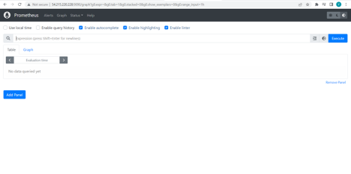

**Successfully we launched the Prometheus application**

Install node exporter in application server

|  | 2. NODE EXPORTER ON APPLICATION SERVER |
| --- | --- |

Server 2 (Node exporter with any appserver)

**Launch the Ubuntu version 20 Virtual Machine:**

Install the ubuntu version 20 from the AWS Cloud

Allow the Inbound rule 9100 which is the port number of node-exporter To install the node-exporter visit the official website site https://prometheus.io For the Installation of node-exporter we have created a below script file Name of the script file is node-exporter.sh

!#/bin/bash

sudo apt update

sudo wget https://github.com/prometheus/node_exporter/releases/d

Stories 3: Infra metrics - Node Exporter - Prometheus Grafana 9

sudo groupadd --system prometheus

sudo useradd -s /sbin/nologin --system -g prometheus prometheus sudo mkdir /var/lib/node

sudo tar xvf node_exporter-1.6.0.linux-amd64.tar.gz cd node_exporter-1.6.0.linux-amd64

sudo mv node_exporter /var/lib/node

sudo tee /etc/systemd/system/node.service<<EOF

[Unit]

Description=Prometheus Node Exporter

Documentation=https://prometheus.io/docs/introduction/overview/ Wants=network-online.target

After=network-online.target

[Service]

Type=simple

User=prometheus

Group=prometheus

ExecReload=/bin/kill -HUP $MAINPID

ExecStart=/var/lib/node/node_exporter

SyslogIdentifier=prometheus_node_exporter

Restart=always

[Install]

WantedBy=multi-user.target

EOF

Stories 3: Infra metrics - Node Exporter - Prometheus Grafana 10

sudo chown -R prometheus:prometheus /var/lib/node

sudo chown -R prometheus:prometheus /var/lib/node/*

sudo chmod -R 775 /var/lib/node

sudo chmod -R 755 /var/lib/node/*

sudo systemctl daemon-reload

sudo systemctl start node

sudo systemctl enable node

Take the public ip of the instance and check in browser for the node-exporter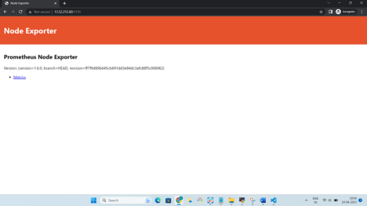Stories 3: Infra metrics - Node Exporter - Prometheus Grafana 11

Configure  Prometheus with node exporter in

Prometheus server by editing Prometheus.yaml file

|  | 3.CONFIGURATIONS OF PROMETHEUS WITH NODE-EXPORTER |
| --- | --- |

Inorder to configure the Prometheus with the node-exporter application server we need to edit the Prometheus.yml file which is located in

/etc/prometheus/prometheus.yml

We need to configure the private ip address of the node-exporter server along with port number.

Here the example will be 31.15.104:9100.

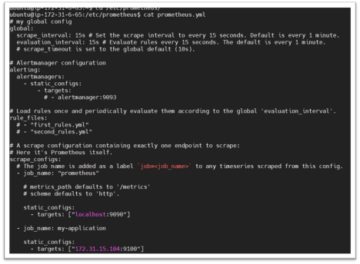

If you check the status of the Prometheus in Targets section you will find the node-exporter status up and running restart the Prometheus

sudo systemctl restart prometheus

Stories 3: Infra metrics - Node Exporter - Prometheus Grafana 12

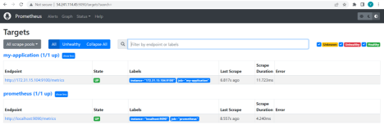

|  | 4. SCRAPING THE METRICS FROM THE APPLICATION SERVER |
| --- | --- |

**FREE RAM METRIC:**

In order to get the free RAM on an application server we need to provide PROMQL Query on the Prometheus server.

node_memory_MemFree_bytes /1024 /1024 /1024

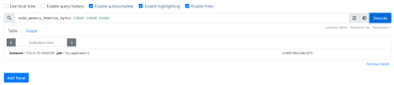Checking the free RAM on the Application Server by the command free -h

Stories 3: Infra metrics - Node Exporter - Prometheus Grafana 13

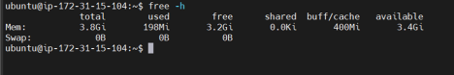

**HARD DISK SPACE:**

In order to scrape the Hard Disk Space from the Application Server we need to Query the Prometheus Server

node_filesystem_avail_bytes /1024 /1024 /1024

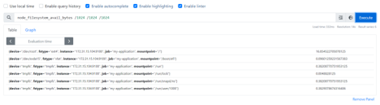

Checking the Hard Disk Space on the Application Server by the command df - h.

Stories 3: Infra metrics - Node Exporter - Prometheus Grafana 14

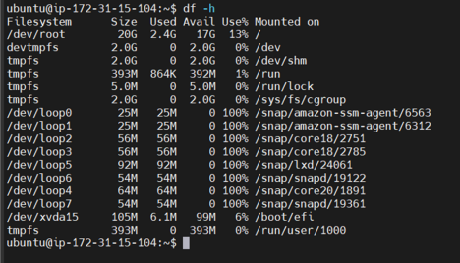

**TOTAL HARD DISK SIZE:**

In order to get the Total Hard Disk Size on an application server we need to provide PROMQL Query on the Prometheus server.

node_filesystem_size_bytes /1024 /1024 /1024

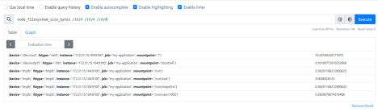

|  | 5. GRAFANA |
| --- | --- |

**Launch the Ubuntu version 20 Virtual Machine:**

Install the ubuntu version 20 from the AWS Cloud

Stories 3: Infra metrics - Node Exporter - Prometheus Grafana 15

Allow the Inbound rule 3000 which is the port number of Grafana To install the Grafana visit the official website site https://grafana.com For the Installation of Grafana we have created a below script file Name of the script file is sh

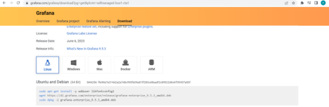

#!/bin/bash

sudo apt-get install -y adduser libfontconfig1

wget https://dl.grafana.com/enterprise/release/grafana-enterpris sudo dpkg -i grafana-enterprise_9.5.3_amd64.deb

sudo systemctl start grafana-server

sudo systemctl enable grafana-server

sudo systemctl status grafana-server

Take the public ip of the instance and check in browser for the Grafana application .

Stories 3: Infra metrics - Node Exporter - Prometheus Grafana 16



**Successfully we launched the Grafana application**

|  | 6. CONFIGURING PROMETHEUS WITH GRAFANA |
| --- | --- |

Login into the Grafana Server with the username and password

After Login into the Grafana goto the Connections option and click on your connections

Click on Add data source and add Prometheus as shown in the below pics

After giving the Prometheus URL click on SAVE&TEST option in order to test the connection between Prometheus and Grafana.

Successfully Prometheus and Grafana configured

Stories 3: Infra metrics - Node Exporter - Prometheus Grafana 17



|  | 6. CONFIGURING PROMETHEUS WITH GRAFANA |
| --- | --- |

Login into the Grafana Server with the username and password 

After Login into the Grafana goto the Connections option and click on your connections

Stories 3: Infra metrics - Node Exporter - Prometheus Grafana 18

Click on Add data source and add Prometheus as shown in the below pics

Stories 3: Infra metrics - Node Exporter - Prometheus Grafana 19

After giving the Prometheus URL click on SAVE&TEST option in order to test

the connection between Prometheus and Grafana.



Successfully Prometheus and Grafana configured

| **7. GRAFANA DASHBOARDS FOR APPLICATION SERVER** |
| --- |
|  |

Creating the Grafana Dashboards of the Application server metrics for FREE

RAM , HARD DISK SPACE , TOTAL HARD DISK SIZE.

1.FREE RAM METRIC:

Creating the Dashboard for the FREE RAM follow the below steps

Create a new folder with the name Digital-lync

Stories 3: Infra metrics - Node Exporter - Prometheus Grafana 20



Now create the Dashboard inside the folder Digital-lync

We need to give the Prometheus query on the Grafana Dashboard as shown below then it will fetch the data from the Application server with the Prometheus Tool.

node_memory_MemFree_bytes /1024 /1024 /1024

Paste the query here

Stories 3: Infra metrics - Node Exporter - Prometheus Grafana 21



The Grafana will fetch the live Free RAM data from the Application server with the provided time intervel

2.HARD DISK SPACE METRIC:

In the same dashboard create a another new visualization for the Hard Disk Space Metric.

Stories 3: Infra metrics - Node Exporter - Prometheus Grafana 22

We need to give the Hard Disk Space Prometheus query on the Grafana Dashboard as shown below then it will fetch the data from the Application server with the Prometheus Tool.

node_filesystem_avail_bytes /1024 /1024 /1024



The Grafana will fetch the live Hard Disk size Sapce data from the Application server.

1. **TOTAL HARD DISK SIZE:**

In the same dashboard create a another new visualization for the Total Hard Disk Space Metric.

We need to give the Total Hard Disk Space Prometheus query on the Grafana Dashboard as shown below then it will fetch the data from the Application server with the Prometheus Tool.

node_filesystem_size_bytes /1024 /1024 /1024

Stories 3: Infra metrics - Node Exporter - Prometheus Grafana 23



The Grafana will fetch the live Total Hard Disk size Sapce data from the Application server .

Stories 3: Infra metrics - Node Exporter - Prometheus Grafana 24